INTRODUCING

The session of First Presbyterian Church of Dunellen is requesting that the Presbytery of Elizabeth dismiss our congregation, upon the Congregation’s agreement to the Session’s recommendation, to the Covenant Order of Evangelical Presbyterians (ECO). ECO is a new and vital denomination that is closely aligned with our theology, vision, and culture as a church. The session believes that ECO presents an environment our church can flourish as we continue to pursue our vision to be: a multicultural family, growing in faith, connecting people with Christ.

In seeking a new denominational home, the session looked for the following distinctive characteristics:

- Solidly evangelical in theology, upholding the inspiration of scripture as the written Word of God, authoritative in all matters of faith and life.
- A clear understanding that God’s plan is for all people to live in fidelity within the covenant of marriage between a man and a woman, or chastity in singleness.
- Upholding of the sanctity of human life from conception until natural death.
- A reformed theological foundation, and preferably a Presbyterian form of government.
- Forward looking and missional in its priorities for ministry.
- Fitting not only the theology, but the “culture” of our congregation, meaning it will celebrate women in leadership, cultural and ethnic diversity, a variety of worship styles, and recognize the full range of spiritual gifts alive in the church today.

ECO was established in January 2012 as an outgrowth of the Fellowship of Presbyterians. ECO is both reformed and evangelical in its theology, as can be seen in its theological position paper and essentials. It upholds the sanctity of life from conception until natural death, and upholds biblical sexual purity.

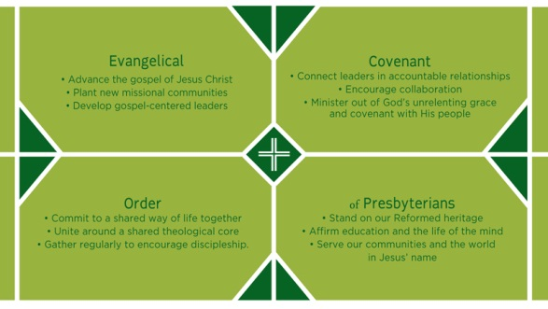ECO is committed to growing and planting flourishing churches that make disciples of Jesus Christ.

As shown here, the name Covenant Order of Evangelical Presbyterians and the acronym ECO reflect significant theological and relational commitments.
The acronym ECO also speaks to the organization’s commitment to strengthen the ecosystems of local churches, providing the resources needed to grow, thrive, and reproduce. Just as earthly ecosystems draw richness from bio-diversity, ECO is committed to unleashing the ministry gifts of women, men, young leaders, and every ethnicity. ECO’s name also resembles the Greek word oikos, meaning household, which is used in the Bible to reference the network of relationships that nurture an individual.

CORE VALUES that have shaped the formation of ECO are:

Jesus-shaped Identity We believe Jesus Christ must be at the center of our lives and that making disciples of Jesus at the core of our ministry.

Biblical Integrity We believe the Bible is the unique and authoritative Word of God, which teaches all that is necessary for faith and life. The prominence of God’s Word over our lives shapes our priorities, and the unrivaled authority of the Bible directs our actions to be in concert with Christ’s very best for our lives.
Thoughtful Theology We believe in theological education, constant learning, and the life of the mind, and celebrate this as one of the treasures of our Reformed heritage.

Accountable Community We believe guidance is a corporate spiritual experience. We want to connect leaders to one another in healthy relationships of accountability, synergy, and care.
Egalitarian Ministry We believe in unleashing the ministry gifts of women, men, and every ethnic group.

Missional Centrality We believe in living out the whole of the Great Commission – including evangelism, spiritual formation, compassion, and redemptive justice – in our communities and around the world.

Center-focused Spirituality We believe in calling people to the core of what it means to be followers of Jesus – what “mere Christianity” is and does – and not fixate on the boundaries.

Leadership Velocity We believe identifying and developing gospel-centered leaders is critical for the church, and a great leadership culture is risk-taking, innovative, and organic.

Kingdom Vitality We believe congregations should vigorously reproduce new missional communities to expand the Kingdom of God.

DIFFERENCES IN STRUCTURE from our current denomination, the Presbyterian Church (USA), include:

- Smaller presbyteries of between 10 and 25 churches, where the focus is on worship together, relationships, and mutual encouragement, accountability and cooperation in ministry.
- Politics, bureaucratic process, and procedure are minimized. Minimal structure and government in order to foster flexibility based on trust and mutually agreed upon core beliefs.
- Clearly stated essential tenets (beliefs) to which all those seeking ordained office must agree.
- Only three levels of church government: session, presbyteries, and a national synod.

THE START OF ECO at the Covenanting Conference in Orlando, which introduced the denomination this January, felt like a reunion gathering of long-time friends. The worship services varied from the very traditional to the very contemporary, but all were vibrant, Christ-centered, Spirit-filled, and transformative. There was an overwhelming sense of optimism and the presence of the Holy Spirit. An opening sermon preached by John Ortberg provided a powerful, biblically-anchored start for this new organization.

Much more information on ECO is available at www.fellowship-pres.org/eco, including John Ortberg’s sermon (which is well worth watching). Copies of ECO's Theology document (which includes a list of essential beliefs) and Polity document can also be obtained from this website, or the church office.

Throughout this process, the session has been committed to moving no faster, and no slower than God. We believe that the birth of this new denomination is an answer to prayer and that now is the time to move. The initial framework of ECO is strong, and together with the other like-minded congregations joining this movement, we prayerfully hope to build a new community of churches that serves Jesus Christ faithfully and effectively in the 21st century. We believe that we see God is moving, and with eyes-wide-open faith, are eager to dive in where the living waters flow!

